Q)Construct an ER diagram for a travel agency

**Main Entities and Their Attributes**

1. **Customer**
   * Customer_ID (PK)
   * Name
   * Email
   * Phone
   * Address
2. **Package**
   * Package_ID (PK)
   * Destination
   * Description
   * Duration
   * Price
3. **Booking**
   * Booking_ID (PK)
   * Booking_Date
   * Total_Amount
   * Customer_ID (FK)
   * Package_ID (FK)
4. **Payment**
   * Payment_ID (PK)
   * Payment_Date
   * Amount
   * Payment_Method
   * Booking_ID (FK)
5. **Travel_Agent**
   * Agent_ID (PK)
   * Name
   * Email
   * Phone
6. **Feedback**
   * Feedback_ID (PK)
   * Comments
   * Rating
   * Customer_ID (FK)
   * Package_ID (FK)

**🔗 Relationships**

* A **Customer** can make **many Bookings** → 1-to-many
* A **Package** can be booked in **many Bookings** → 1-to-many
* A **Booking** can have **one Payment**
* A **Travel Agent** can manage **many Bookings** (optional) → 1-to-many
* A **Customer** can leave **Feedback** for multiple **Packages** → many-to-many

Q) Construct an ER diagram for a Library management system

**Main Entities and Attributes**

1. **Book**
   * Book_ID (PK)
   * Title
   * Author
   * Publisher
   * ISBN
   * Genre
   * Year_Published
   * Quantity
2. **Member**
   * Member_ID (PK)
   * Name
   * Email
   * Phone
   * Address
   * Membership_Date
3. **Loan**
   * Loan_ID (PK)
   * Issue_Date
   * Due_Date
   * Return_Date
   * Book_ID (FK)
   * Member_ID (FK)
4. **Librarian**
   * Librarian_ID (PK)
   * Name
   * Email
   * Phone
5. **Fine**
   * Fine_ID (PK)
   * Amount
   * Date_Issued
   * Loan_ID (FK)

**🔗 Relationships**

* A **Member** can borrow multiple **Books** via **Loans** → 1-to-many
* A **Book** can be issued in many **Loans** → 1-to-many
* A **Loan** can incur **one Fine** (optional) → 1-to-1 (optional)
* A **Librarian** can manage many **Loans** → 1-to-many

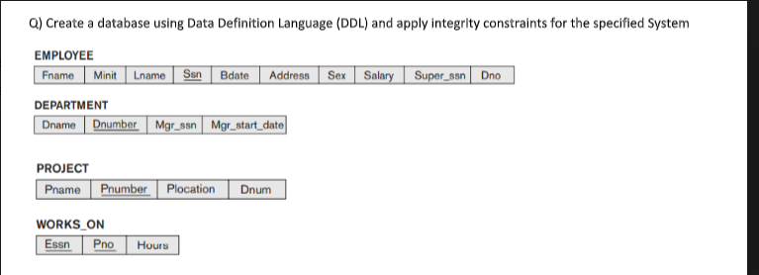

CREATE TABLE EMPLOYEE (

Fname VARCHAR(30) NOT NULL,

Minit CHAR(1),

Lname VARCHAR(30) NOT NULL,

Ssn CHAR(9) PRIMARY KEY,

Bdate DATE,

Address VARCHAR(100),

Sex CHAR(1),

Salary DECIMAL(10, 2),

Super_ssn CHAR(9),

Dno INT,

FOREIGN KEY (Super_ssn) REFERENCES EMPLOYEE(Ssn),

FOREIGN KEY (Dno) REFERENCES DEPARTMENT(Dnumber)

);

-- DEPARTMENT Table

CREATE TABLE DEPARTMENT (

Dname VARCHAR(50) NOT NULL,

Dnumber INT PRIMARY KEY,

Mgr_ssn CHAR(9),

Mgr_start_date DATE,

FOREIGN KEY (Mgr_ssn) REFERENCES EMPLOYEE(Ssn)

);

-- PROJECT Table

CREATE TABLE PROJECT (

Pname VARCHAR(50) NOT NULL,

Pnumber INT PRIMARY KEY,

Plocation VARCHAR(50),

Dnum INT,

FOREIGN KEY (Dnum) REFERENCES DEPARTMENT(Dnumber)

);

-- WORKS_ON Table

CREATE TABLE WORKS_ON (

Essn CHAR(9),

Pno INT,

Hours DECIMAL(5,2),

PRIMARY KEY (Essn, Pno),

FOREIGN KEY (Essn) REFERENCES EMPLOYEE(Ssn),

FOREIGN KEY (Pno) REFERENCES PROJECT(Pnumber)

);

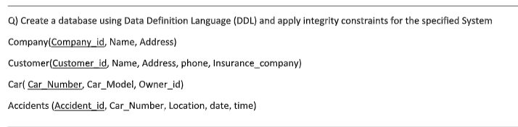

-- COMPANY Table

CREATE TABLE Company (

Company_id INT PRIMARY KEY,

Name VARCHAR(100) NOT NULL,

Address VARCHAR(200)

);

-- CUSTOMER Table

CREATE TABLE Customer (

Customer_id INT PRIMARY KEY,

Name VARCHAR(100) NOT NULL,

Address VARCHAR(200),

Phone VARCHAR(15),

Insurance_company INT,

FOREIGN KEY (Insurance_company) REFERENCES Company(Company_id)

);

-- CAR Table

CREATE TABLE Car (

Car_Number VARCHAR(20) PRIMARY KEY,

Car_Model VARCHAR(50),

Owner_id INT,

FOREIGN KEY (Owner_id) REFERENCES Customer(Customer_id)

);

-- ACCIDENTS Table

CREATE TABLE Accidents (

Accident_id INT PRIMARY KEY,

Car_Number VARCHAR(20),

Location VARCHAR(100),

Date DATE,

Time TIME,

FOREIGN KEY (Car_Number) REFERENCES Car(Car_Number)

);

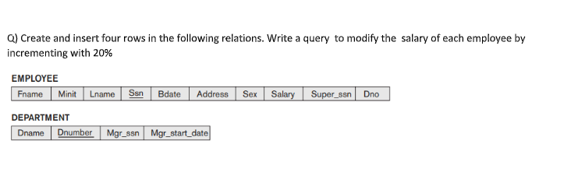

CREATE TABLE DEPARTMENT (

Dname VARCHAR(50) NOT NULL,

Dnumber INT PRIMARY KEY,

Mgr_ssn CHAR(9),

Mgr_start_date DATE

);

CREATE TABLE EMPLOYEE (

Fname VARCHAR(30) NOT NULL,

Minit CHAR(1),

Lname VARCHAR(30) NOT NULL,

Ssn CHAR(9) PRIMARY KEY,

Bdate DATE,

Address VARCHAR(100),

Sex CHAR(1),

Salary DECIMAL(10, 2),

Super_ssn CHAR(9),

Dno INT,

FOREIGN KEY (Super_ssn) REFERENCES EMPLOYEE(Ssn),

FOREIGN KEY (Dno) REFERENCES DEPARTMENT(Dnumber)

);

-- Insert into DEPARTMENT

INSERT INTO DEPARTMENT VALUES

('HR', 1, '123456789', '2020-01-01'),

('IT', 2, '987654321', '2021-02-15'),

('Finance', 3, '456123789', '2019-07-01'),

('Marketing', 4, '789456123', '2022-06-30');

-- Insert into EMPLOYEE

INSERT INTO EMPLOYEE VALUES

('John', 'A', 'Doe', '123456789', '1990-05-15', '123 Elm St', 'M', 50000, NULL, 1),

('Jane', 'B', 'Smith', '987654321', '1988-09-23', '456 Oak St', 'F', 60000, '123456789', 2),

('Alice', 'C', 'Brown', '456123789', '1992-11-30', '789 Pine St', 'F', 55000, '987654321', 3),

('Bob', 'D', 'White', '789456123', '1985-04-10', '321 Maple St', 'M', 52000, '456123789', 4);

UPDATE EMPLOYEE

SET Salary = Salary * 1.2;

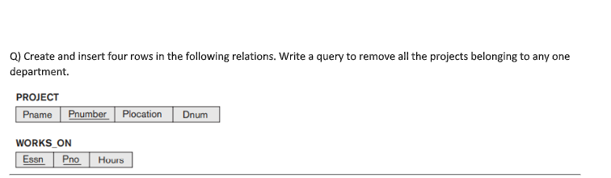

-- PROJECT table

CREATE TABLE PROJECT (

Pname VARCHAR(50) NOT NULL,

Pnumber INT PRIMARY KEY,

Plocation VARCHAR(100),

Dnum INT

);

-- WORKS_ON table

CREATE TABLE WORKS_ON (

Essn CHAR(9),

Pno INT,

Hours DECIMAL(5,2),

PRIMARY KEY (Essn, Pno),

FOREIGN KEY (Pno) REFERENCES PROJECT(Pnumber)

);

-- Insert into PROJECT

INSERT INTO PROJECT VALUES

('Project A', 101, 'New York', 1),

('Project B', 102, 'Chicago', 2),

('Project C', 103, 'San Francisco', 1),

('Project D', 104, 'Houston', 3);

-- Insert into WORKS_ON

INSERT INTO WORKS_ON VALUES

('123456789', 101, 20.5),

('987654321', 102, 15.0),

('456123789', 103, 18.0),

('789456123', 104, 25.0);

DELETE FROM PROJECT

WHERE Dnum = 1;

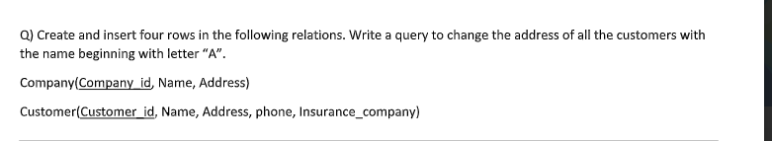

-- COMPANY table

CREATE TABLE Company (

Company_id INT PRIMARY KEY,

Name VARCHAR(100) NOT NULL,

Address VARCHAR(200)

);

-- CUSTOMER table

CREATE TABLE Customer (

Customer_id INT PRIMARY KEY,

Name VARCHAR(100) NOT NULL,

Address VARCHAR(200),

Phone VARCHAR(15),

Insurance_company INT,

FOREIGN KEY (Insurance_company) REFERENCES Company(Company_id)

);

-- Insert into COMPANY

INSERT INTO Company VALUES

(1, 'SafeGuard Insurance', '101 Market St'),

(2, 'SecureLife Corp', '202 River Rd'),

(3, 'Aegis Insurance', '303 Hilltop Blvd'),

(4, 'TrustShield Inc.', '404 Valley View');

-- Insert into CUSTOMER

INSERT INTO Customer VALUES

(101, 'Alice Johnson', '12 Apple St', '1234567890', 1),

(102, 'Bob Smith', '34 Berry Blvd', '2345678901', 2),

(103, 'Andrew Lee', '56 Cherry Ln', '3456789012', 3),

(104, 'Clara Davis', '78 Date Dr', '4567890123', 4);

UPDATE Customer

SET Address = 'Updated Address'

WHERE Name LIKE 'A%';

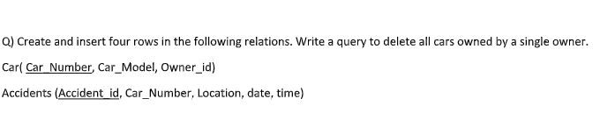

-- CAR table

CREATE TABLE Car (

Car_Number VARCHAR(15) PRIMARY KEY,

Car_Model VARCHAR(50),

Owner_id INT

);

-- ACCIDENTS table

CREATE TABLE Accidents (

Accident_id INT PRIMARY KEY,

Car_Number VARCHAR(15),

Location VARCHAR(100),

date DATE,

time TIME,

FOREIGN KEY (Car_Number) REFERENCES Car(Car_Number)

);

-- Insert into CAR

INSERT INTO Car VALUES

('MH12AB1234', 'Toyota Corolla', 1),

('MH12AB5678', 'Honda Civic', 2),

('MH12CD9012', 'Ford Focus', 1),

('MH12EF3456', 'Hyundai Elantra', 3);

-- Insert into ACCIDENTS

INSERT INTO Accidents VALUES

(101, 'MH12AB1234', 'Mumbai', '2024-01-10', '10:00:00'),

(102, 'MH12AB5678', 'Pune', '2024-02-12', '12:30:00'),

(103, 'MH12CD9012', 'Nashik', '2024-03-15', '08:45:00'),

(104, 'MH12EF3456', 'Nagpur', '2024-04-01', '14:15:00');

DELETE FROM Car

WHERE Owner_id = 1;

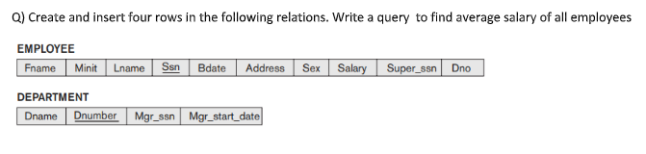

-- DEPARTMENT table

CREATE TABLE Department (

Dname VARCHAR(50),

Dnumber INT PRIMARY KEY,

Mgr_ssn CHAR(9),

Mgr_start_date DATE

);

-- EMPLOYEE table

CREATE TABLE Employee (

Fname VARCHAR(50),

Minit CHAR(1),

Lname VARCHAR(50),

Ssn CHAR(9) PRIMARY KEY,

Bdate DATE,

Address VARCHAR(200),

Sex CHAR(1),

Salary DECIMAL(10, 2),

Super_ssn CHAR(9),

Dno INT,

FOREIGN KEY (Dno) REFERENCES Department(Dnumber),

FOREIGN KEY (Super_ssn) REFERENCES Employee(Ssn)

);

-- Insert into DEPARTMENT

INSERT INTO Department VALUES

('HR', 1, '123456789', '2022-01-01'),

('IT', 2, '987654321', '2022-02-01'),

('Finance', 3, '112233445', '2022-03-01'),

('Marketing', 4, '556677889', '2022-04-01');

-- Insert into EMPLOYEE

INSERT INTO Employee VALUES

('John', 'A', 'Doe', '111111111', '1990-01-01', '123 Elm St', 'M', 50000, NULL, 1),

('Jane', 'B', 'Smith', '222222222', '1985-02-02', '456 Oak St', 'F', 60000, '111111111', 2),

('Alice', 'C', 'Brown', '333333333', '1992-03-03', '789 Pine St', 'F', 55000, '111111111', 3),

('Bob', 'D', 'Johnson', '444444444', '1988-04-04', '321 Maple St', 'M', 65000, '222222222', 4);

SELECT AVG(Salary) AS Average_Salary

FROM Employee;

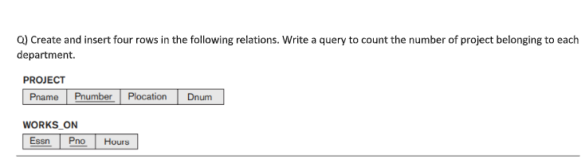

-- PROJECT table

CREATE TABLE Project (

Pname VARCHAR(50),

Pnumber INT PRIMARY KEY,

Plocation VARCHAR(100),

Dnum INT

);

-- WORKS_ON table

CREATE TABLE Works_On (

Essn CHAR(9),

Pno INT,

Hours DECIMAL(5, 2),

FOREIGN KEY (Pno) REFERENCES Project(Pnumber)

);

-- Insert into PROJECT

INSERT INTO Project VALUES

('AI Research', 101, 'New York', 1),

('Web Dev', 102, 'Chicago', 2),

('App Dev', 103, 'Seattle', 1),

('Security Audit', 104, 'Boston', 3);

-- Insert into WORKS_ON

INSERT INTO Works_On VALUES

('111111111', 101, 20),

('222222222', 102, 25),

('333333333', 103, 30),

('444444444', 104, 15);

SELECT Dnum, COUNT(*) AS Project_Count

FROM Project

GROUP BY Dnum;

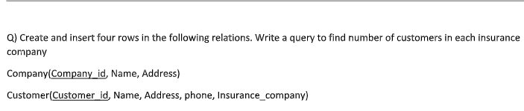

-- COMPANY table

CREATE TABLE Company (

Company_id INT PRIMARY KEY,

Name VARCHAR(100),

Address VARCHAR(200)

);

-- CUSTOMER table

CREATE TABLE Customer (

Customer_id INT PRIMARY KEY,

Name VARCHAR(100),

Address VARCHAR(200),

Phone VARCHAR(15),

Insurance_company VARCHAR(100)

);

-- Insert into COMPANY

INSERT INTO Company VALUES

(1, 'SafeLife Insurance', 'New York'),

(2, 'HealthFirst Co.', 'Boston'),

(3, 'SecureCare', 'Chicago'),

(4, 'LifeShield', 'Seattle');

-- Insert into CUSTOMER

INSERT INTO Customer VALUES

(101, 'Alice Johnson', 'NY', '1234567890', 'SafeLife Insurance'),

(102, 'Bob Smith', 'LA', '2345678901', 'HealthFirst Co.'),

(103, 'Amy Adams', 'TX', '3456789012', 'SafeLife Insurance'),

(104, 'Daniel Grey', 'CA', '4567890123', 'SecureCare');

SELECT Insurance_company, COUNT(*) AS Customer_Count

FROM Customer

GROUP BY Insurance_company;

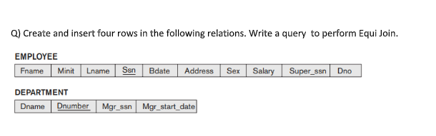

-- DEPARTMENT table

CREATE TABLE DEPARTMENT (

Dname VARCHAR(50),

Dnumber INT PRIMARY KEY,

Mgr_ssn VARCHAR(9),

Mgr_start_date DATE

);

-- EMPLOYEE table

CREATE TABLE EMPLOYEE (

Fname VARCHAR(50),

Minit CHAR(1),

Lname VARCHAR(50),

Ssn VARCHAR(9) PRIMARY KEY,

Bdate DATE,

Address VARCHAR(200),

Sex CHAR(1),

Salary DECIMAL(10, 2),

Super_ssn VARCHAR(9),

Dno INT,

FOREIGN KEY (Dno) REFERENCES DEPARTMENT(Dnumber)

);

-- Insert into DEPARTMENT

INSERT INTO DEPARTMENT VALUES

('HR', 1, '123456789', '2015-01-01'),

('IT', 2, '987654321', '2018-03-15'),

('Finance', 3, '555666777', '2019-07-01'),

('Marketing', 4, '888999000', '2020-11-11');

-- Insert into EMPLOYEE

INSERT INTO EMPLOYEE VALUES

('Alice', 'A', 'Brown', '111111111', '1990-01-01', 'NY', 'F', 60000, NULL, 1),

('Bob', 'B', 'Smith', '222222222', '1985-06-15', 'LA', 'M', 75000, '111111111', 2),

('Cathy', 'C', 'Jones', '333333333', '1992-09-10', 'TX', 'F', 65000, '222222222', 3),

('David', 'D', 'Lee', '444444444', '1988-12-22', 'CA', 'M', 70000, '333333333', 2);

SELECT

E.Fname, E.Lname, E.Ssn, D.Dname, D.Dnumber

FROM

EMPLOYEE E, DEPARTMENT D

WHERE

E.Dno = D.Dnumber;

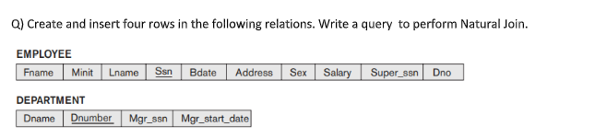

CREATE TABLE EMPLOYEE (

Fname VARCHAR(20),

Minit CHAR(1),

Lname VARCHAR(20),

Ssn CHAR(9) PRIMARY KEY,

Bdate DATE,

Address VARCHAR(50),

Sex CHAR(1),

Salary DECIMAL(10,2),

Super_ssn CHAR(9),

Dno INT

);

CREATE TABLE DEPARTMENT (

Dname VARCHAR(20),

Dnumber INT PRIMARY KEY,

Mgr_ssn CHAR(9),

Mgr_start_date DATE

);

-- Inserting into EMPLOYEE

INSERT INTO EMPLOYEE VALUES

('John', 'A', 'Doe', '123456789', '1990-05-14', 'Pune', 'M', 50000, NULL, 1),

('Jane', 'B', 'Smith', '987654321', '1992-07-20', 'Mumbai', 'F', 60000, '123456789', 2),

('Alex', 'C', 'Brown', '456789123', '1988-03-30', 'Delhi', 'M', 55000, '987654321', 1),

('Sara', 'D', 'Lee', '789123456', '1995-11-11', 'Nagpur', 'F', 48000, '123456789', 3);

-- Inserting into DEPARTMENT

INSERT INTO DEPARTMENT VALUES

('HR', 1, '123456789', '2020-01-01'),

('IT', 2, '987654321', '2021-02-15'),

('Finance', 3, '789123456', '2019-06-20'),

('Admin', 4, '456789123', '2022-09-05');

-- Alter DEPARTMENT table column for Natural Join (only if necessary)

ALTER TABLE DEPARTMENT RENAME COLUMN Dnumber TO Dno;

-- Natural Join Query

SELECT *

FROM EMPLOYEE

NATURAL JOIN DEPARTMENT;

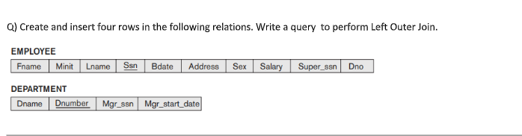

CREATE TABLE EMPLOYEE (

Fname VARCHAR(20),

Minit CHAR(1),

Lname VARCHAR(20),

Ssn CHAR(9) PRIMARY KEY,

Bdate DATE,

Address VARCHAR(50),

Sex CHAR(1),

Salary DECIMAL(10,2),

Super_ssn CHAR(9),

Dno INT

);

CREATE TABLE DEPARTMENT (

Dname VARCHAR(20),

Dnumber INT PRIMARY KEY,

Mgr_ssn CHAR(9),

Mgr_start_date DATE

);

-- Inserting into EMPLOYEE

INSERT INTO EMPLOYEE VALUES

('John', 'A', 'Doe', '123456789', '1990-05-14', 'Pune', 'M', 50000, NULL, 1),

('Jane', 'B', 'Smith', '987654321', '1992-07-20', 'Mumbai', 'F', 60000, '123456789', 2),

('Alex', 'C', 'Brown', '456789123', '1988-03-30', 'Delhi', 'M', 55000, '987654321', 3),

('Sara', 'D', 'Lee', '789123456', '1995-11-11', 'Nagpur', 'F', 48000, '123456789', NULL); -- No department

-- Inserting into DEPARTMENT

INSERT INTO DEPARTMENT VALUES

('HR', 1, '123456789', '2020-01-01'),

('IT', 2, '987654321', '2021-02-15'),

('Finance', 3, '456789123', '2019-06-20'),

('Admin', 4, '789123456', '2022-09-05');

SELECT *

FROM EMPLOYEE E

LEFT OUTER JOIN DEPARTMENT D

ON E.Dno = D.Dnumber;

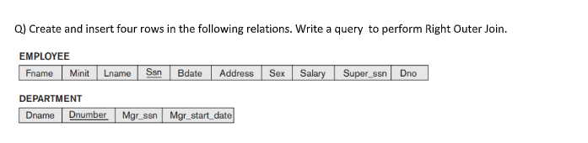

CREATE TABLE EMPLOYEE (

Fname VARCHAR(20),

Minit CHAR(1),

Lname VARCHAR(20),

Ssn CHAR(9) PRIMARY KEY,

Bdate DATE,

Address VARCHAR(50),

Sex CHAR(1),

Salary DECIMAL(10,2),

Super_ssn CHAR(9),

Dno INT

);

CREATE TABLE DEPARTMENT (

Dname VARCHAR(20),

Dnumber INT PRIMARY KEY,

Mgr_ssn CHAR(9),

Mgr_start_date DATE

);

-- Inserting into EMPLOYEE

INSERT INTO EMPLOYEE VALUES

('John', 'A', 'Doe', '123456789', '1990-05-14', 'Pune', 'M', 50000, NULL, 1),

('Jane', 'B', 'Smith', '987654321', '1992-07-20', 'Mumbai', 'F', 60000, '123456789', 2),

('Alex', 'C', 'Brown', '456789123', '1988-03-30', 'Delhi', 'M', 55000, '987654321', 3),

('Sara', 'D', 'Lee', '789123456', '1995-11-11', 'Nagpur', 'F', 48000, '123456789', NULL); -- No department

-- Inserting into DEPARTMENT

INSERT INTO DEPARTMENT VALUES

('HR', 1, '123456789', '2020-01-01'),

('IT', 2, '987654321', '2021-02-15'),

('Finance', 3, '456789123', '2019-06-20'),

('Admin', 4, '789123456', '2022-09-05');

SELECT *

FROM EMPLOYEE E

RIGHT OUTER JOIN DEPARTMENT D

ON E.Dno = D.Dnumber;